Timothy Steen

Stephanie Jurgiel

John Radkins

Tyler Gerber

Enter DC

Undergraduate Seminar in IGM

**Table of Contents**

1. Historical Background
2. Units
3. The Map
4. Rules
   1. Setting Up
      1. Sides
      2. Choosing Units
      3. Placing Ambient Tiles
      4. Starting Position
      5. Determining Turn Order
   2. The Turn
   3. GamePlay
      1. Goal: Capturing Strong Points
      2. Movement
      3. Rubble
      4. Combat
      5. Sides
      6. Combat Chart
      7. Disables/Pinned
      8. Special Units
      9. Garrisoning Buildings
5. The Goals - Win/Lose
   1. Defender
   2. Invader
6. Player Interaction
7. Unit Types
8. Playtests
9. Balance
10. Group Dynamics
11. Issues That We had
12. Future Improvements
13. Success
14. **Historical Background**

In 2026, following years of territorial conflicts and proxy wars, the world’s second cold war turned hot. Resource shortages and the resulting economic crisis forced the European Union to formally band together and militarize while the United States of America jealously guarded what remaining strategic reserves it still possessed. After months of standoff, the Gibraltar Crisis finally escalated, causing the two powers to go to war. After smashing the US Atlantic Fleet, the EU successfully invaded the East Coast of the United States, with battles raging from Boston to Atlanta and Mobile to Houston.

After several disastrous routes, the battered remnants of the US Fifth Army retreated to Washington DC. Now almost a third of its former strength, the Fifth Army has been cut off and surrounded by the forces of the Combined European Second Army, with only the central downtown area and the Washington Mall still under the control of the United States. The White House, the Lincoln Memorial, and the United States Capitol Building have become strong points that are vital to the the survival of the defending forces. What’s left of the Fifth must prepare to defend both its capital and remaining commanders as the EU invades DC with its prize set as the White House.

Losing control of the Lincoln Memorial and the Capitol Building would be devastating to the US force, so they must be careful not to lose the remaining buildings they have left. The loss of the White House causes the entire city to collapse. Should DC and the US forces remaining there fall, the entire American Eastern Seaboard will be taken and the back of the American resistance broken. However, if the Fifth can hold out long enough to be relieved by the remaining US military, the Eastern Seaboard Front would be split in two and the European staging grounds on the coast seriously threatened. The outcome of the Atlantic War rests on the Battle of Washington.

The game draws inspiration from some of the more infamous city battles of modern history, most notably the battles of Stalingrad and Berlin. The game simulates the claustrophobic *rattenkrieg* combat of urban warfare where tanks get stuck and overrun in the streets while infantry fight room-to-room and where battle lines are measured in feet and yards instead of miles. While there are several defined strong points that units fight over, several de facto strong points like crucial intersections, street corners, and bridgeheads rise up during game play. However, the map is not entirely close quarters. The Washington Mall opens up combat and allows much greater maneuverability and fast-paced combat, particularly for vehicles.

1. **Units**

Both the invader (EU) and the defender (US) have a variety of units available to them that differ from the units of the other team. However for balancing purposes, each team has relatively similar unit types and similar numbers for attack, defense, movement, and attack range values. The general types of units include infantry, light-armored infantry fighting vehicles (IFVs), transport vehicles, heavy armored units, and tanks.

Both the invader and the defender share the same infantry units, which are Infantry Squads, Sniper Squads, and Anti-Tank Squads. However, the weapons used for each team differ. The US infantry for example use M16A4s, M4s, and M249SAWs, while the EU infantry use HK G36s, FAMASs, and FN minimi. We chose these units and weapons because they are modern units and weapons that are used in combat today, and if this battle between the US and the EU were to actually occur, we believe this would be a realistic scenario.

Also, for attack, defense, movement, and attack range values of infantry, we chose numbers that appeared to be most suitable and balanced for the units. Infantry can move quickly, and have attack and attack range values based on their weapon types. Infantry squads are the basic infantry units while the other infantry are more specialized. Snipers have a high attack value and attack range, as they are a powerful unit that could possibly realistically one-hit a target from quite a distance, and anti-tank squads have a high attack to represent their power, but a lower attack range than snipers, as their weapons cannot shoot as far as a sniper’s can.

Our units also have defense values based on the direction the unit is facing. In the charts below, units with different defense values for different sides is indicated by multiple numbers in the Defense Value column. The order for the values in the table is: front, sides, back. The counter for each unit shows which way a unit is facing after it has been moved, indicated by an triangle on the “front” of the unit. If attacked, the defense value of the unit depends on which side of the unit is facing the attacking unit. For example, Our Heavy Armor: M1A4 Abrams MBT has a defense value in the front of 8, a defense value on the sides of 7, and a defense value in the back of 6. We decided that defense values should be based on where the weak points of that unit are. Because foot units are pretty evenly vulnerable on both sides, their defense values do not change based on which direction they are facing.

The US M1 Abrams has a smaller range and moves slightly slower but has a greater defense and attack than the Leopard 2 MBT. The US has no unit directly equivalent to the EU AMX30 B2 and the B1 Centauro Tank Destroyer, which are both classified as light tanks; being more lightly armed and armored but having greater movement than the heavier Main Battle Tanks. The US M2 Bradley and Strykers, and the EU DARDO and Warrior are all Infantry Fighting Vehicles (IFVs). IFVs have attributes approaching tanks but with generally less damage and defense but more mobility. In addition, IFVs can house and transport 1 unit of infantry. The US HMMWV is a lightly armed and armored transport that can transport 1 infantry unit quickly throughout the map and has no EU equivalent. If an IFV or HMMWV is destroyed with a unit inside it, the infantry is destroyed as well.

Infantry squads are general all-purpose combat units. Infantry Anti-Tank Squads have low defense and are weak against enemy infantry but very effective against tanks. Snipers have a high attack against infantry and a low attack against tanks.

|  |  |  |  |  |  |  |
| --- | --- | --- | --- | --- | --- | --- |
|  | Unit Name | Attack Value | Defense Value | Movement Value | Attacking Range | Count |
| **US** |  |  |  |  |  |  |
| Unit Type | Specific Unit |  |  |  |  |  |
| Heavy Armor | M1A1 Abrams MBT | 6 | 9_7 _4 | 4 | 4 | 7 |
| IFV (Light Armor) | M2 Bradley | 4 | 7_ 6_4 | 5 | 4 | 7 |
| IFV (Light Armor) | Stryker (AT) | 4 | 6_ 5_4 | 6 | 4 | 5 |
| Transport | HMMWV | 2 | 4 | 7 | 2 | 2 |
| Infantry | Infantry Squad (M16A4, M4, M249SAW) | 4 | 6 | 5 | 4 | 17 |
| Infantry | Sniper team (M24) | 6 (Infantry) 1(Vehicles) | 4 | 4 | 6 | 5 |
| Infantry | Anti-tank squad (M16A4, FGM-148 Javelin) | 6 (Vehicles) 2(Infantry) | 6 | 4 | 4 | 7 |
|  |  |  |  |  |  |  |
| **EU** |  |  |  |  |  |  |
| Heavy Tank | Leopard2 MBT | 5 | 8,7,6 | 5 | 5 | 6 |
| Light Tank | AMX 30B2 | 4 | 7, 6,4 | 6 | 4 | 4 |
| Light Tank | B1 Centauro Tank Destroyer | 6 | 5, 5,4 | 3 | 5 | 4 |
| IFV | DARDO IFV | 4 | 6, 5,4 | 4 | 3 | 4 |
| IFV | FV510 Warrior IFV | 3 | 6, 6,4 | 4 | 4 | 4 |
| Infantry | Infantry squad (HK G36, FAMAS, FN minimi) | 4 | 6 | 5 | 4 | 17 |
| Infantry | Sniper Team (L115A3) | 6 (Infantry) 1(Vehicles) | 4 | 4 | 6 | 5 |
| Infantry | Anti-tank squad (HK G36, Panzer Faust 3) | 6 (Vehicles) 2(Infantry) | 6 | 4 | 4 | 6 |

1. **The Map**

The map is an aerial, realistic view of the center of Washington D.C. and important surrounding areas and buildings, divided into hex tiles. The three focal point buildings are the White House close to the center of the board, the Lincoln Memorial and the Capitol Building to the left and right of the white house respectively, where they can be found in reality.

Invader units are allowed to start on any perimeter hex-tile on the outside of the map, as they have fully surrounded the city. Defender units can start anywhere on the map that is more than 4 tiles away from the perimeter, as to keep the defenders from completely blocking the invader units before the game has even begun.

The map contains many road tiles that can be used by both sides to move units quickly and with ease. Roads, grass tiles, and bridges are the only tiles on which tanks may move.

The Potomac River appears on the left of the map with indestructible orange bridge tiles crossing it. These areas are involved in starting points for the invader, and therefore can be either strategically used or defended by either team. Invader units could decide to place units along the river at the start of the game to make capturing strong points quick and easy, which gives the defender the incentive to travel quickly towards the river to defend there.

Rubble wall tiles can also be placed on the map. Infantry units can use them to take cover, receiving +1 to defense. Vehicles may pass over the rubble wall, but must roll to see if they stall out.

The map contains many buildings in which units can garrison to gain range and defence bonuses.

Map of Washington D.C. Our Map

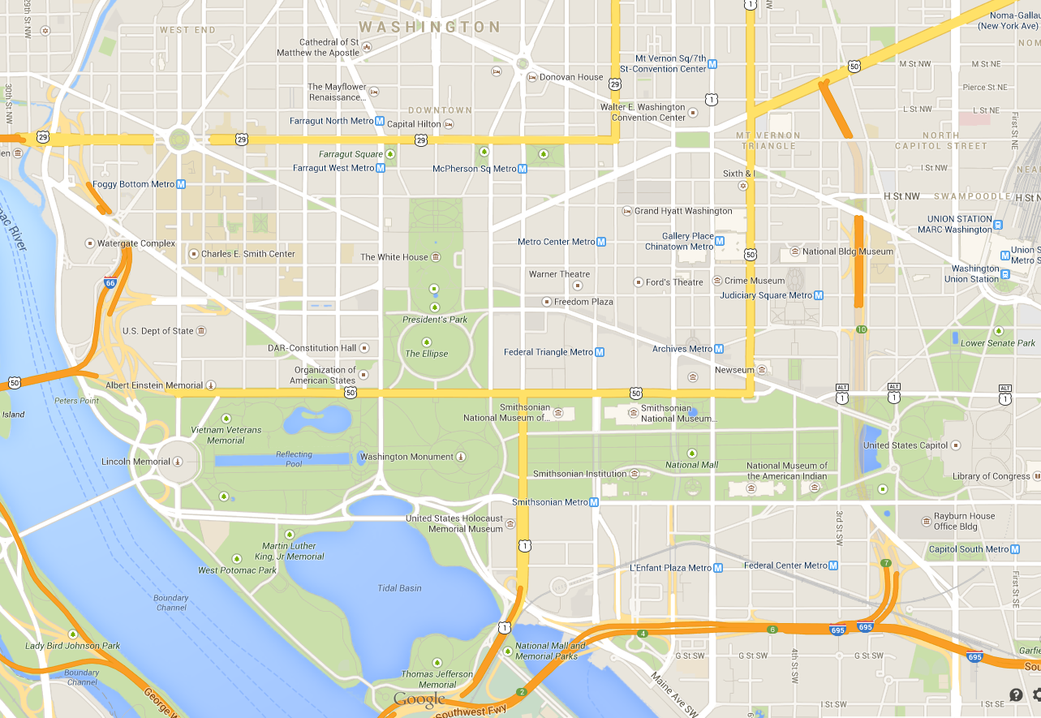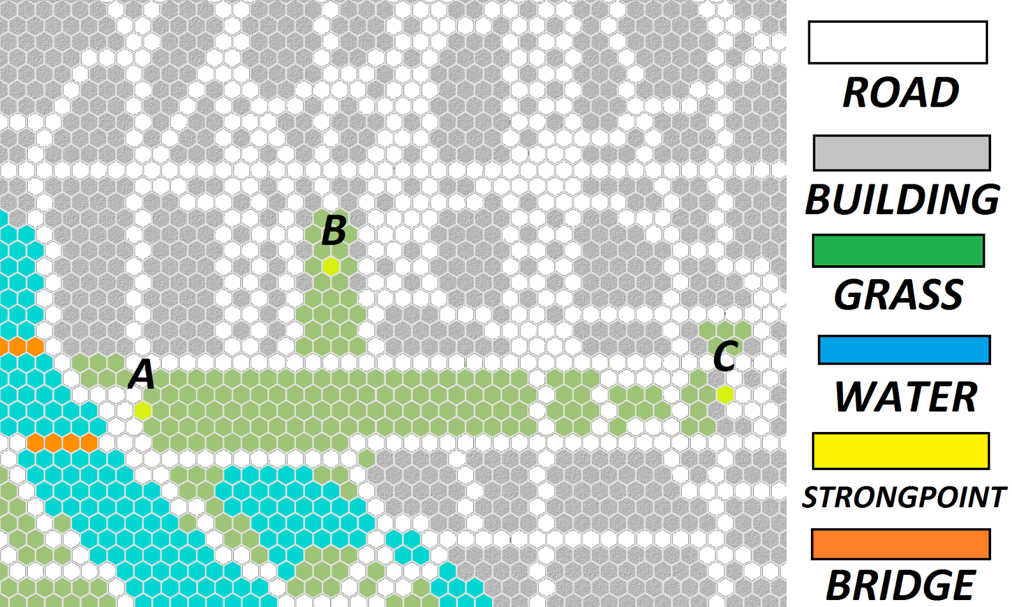

1. **Rules**
2. Setting Up
   1. Sides
      1. There are two sides:
         1. The Invader (The Combined European Second Army) (EU)
            1. The European units are colored light green.
         2. The Defender (The US Fifth Army) (USA)
            1. The US units are colored light blue.
      2. Both players choose a side.
   2. Choosing Units
      1. The defender (US) chooses 35 of any defender type unit tiles from the bag labeled “US”.
      2. The invader (EU) chooses 35 of any invader type unit tiles from the bag labeled “EU”.
   3. Placing Ambient Tiles
      1. Before placing any units, rubble tiles must be placed.
      2. Both teams get five tiles of rubble each and must place them on the board.
         1. The rubble tiles cannot be placed on building tiles, water tiles, bridges (road tiles over water), or any of the tiles that the invaders can spawn on.
   4. Starting Positions
      1. **The Invader** places his or her pieces first.
      2. **The Invader (EU):** The invader can only start on any hex tile along the perimeter of the board that are road or open tiles. Starting invader units cannot start on a building tile or in the river.
         1. NOTE: if at least half of the tile is cut off by the edge of the map, then the invader may place a unit on an adjacent open tile.
      3. **The Defender (US):** The defender can start anywhere within the board that is more than 5 hex tiles away from the perimeter of the board. Vehicles must start on open or road tiles. Infantry can start in building adjacent to road tiles. Each strongpoint requires 1 infantry to be placed on it (Anti-Tank Squad, Sniper, Infantry Squad).
      4. NOTE: The orientation of the vehicle matters. The frontal armor (designated by the arrow on the tile) is the strongest. See “Sides” for more details.

v. Determining turn Order

1. The **Invader always** goes **first.**

**b. The Turn:** The game is turn based.

1. **During Invader’s Turn:** Place any new reinforcement directly next to a controlled strong point or around the edges of the board. (See “Capturing Strongpoints” for more details.)
2. **Movement:** The player may move any or all of his units up to the number of spaces specified by the movement speed on the unit piece.
3. **Attacking:** When the player finishes movement for a piece they can check if any opposing units are “in range” and “in line of sight” of his unit. If so, combat may be initiated. If the player attacks, they may no longer move that unit for that turn and may only resolve combat. There can be multiple battles on the map during a turn.
   1. “In range” refers to the range value specified on the unit tile.
   2. “Line of sight” is determined by if a straight line can be connected between the two units without any obstructions.
4. **Game Play**

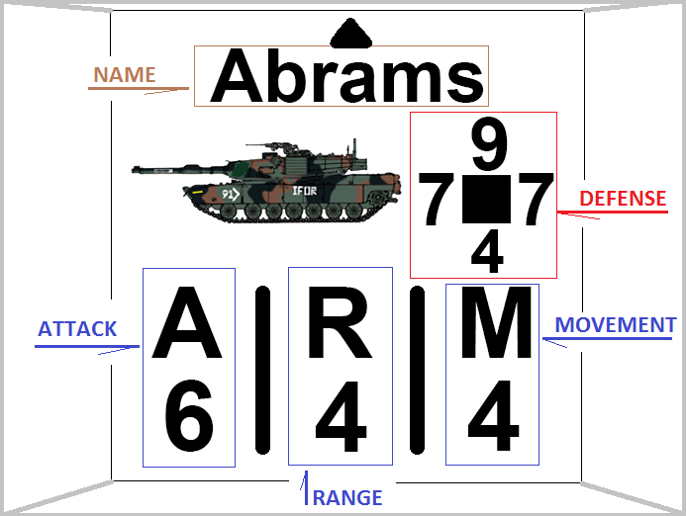

* 1. Capturing Strongpoints
     1. The Defender starts the game controlling all 3 strongpoints (Yellow Tiles on the board): The White House, the Lincoln Memorial, and the United States Capitol Building.
     2. If at any point in the turn an infantry moves onto and stays on a strong point until the next turn, that player gains control over the Strongpoint. The infantry can move off of the strong point and still retain control of it.
     3. The Invader wins the game when he or she captures the White House (see “Win/Lose” for more information).
     4. In addition, the Invader receives one extra reinforcement per turn for every strongpoint he or she holds.
        1. Ex. Number of reinforcements per turn = 1 + # of Strongpoints held.
  2. Movement
     1. Each unit is capable moving the number of hex tiles indicated on their tile. The player can choose not to travel the full distance.
     2. Tiles:
        1. All units can move on Road (dark gray) and Grass (green) tiles with no penalty.
        2. Building tiles (light gray) are impassable to all vehicles.
           1. Infantry can move through building tiles at the cost of 1 extra movement.
           2. In addition, infantry gains bonuses while occupying a building tile. (see below: “*Garrisoning* *Buildings”*)
        3. Water tiles (blue) are impassable by all units.
        4. Strongpoint Tiles (yellow) contain the same properties as building tiles. However, these tiles contain special rules for the player that holds them. More information about these tiles can be found on the section labeled “*Capturing Strongpoints*” located directly above.
     3. No unit can be moved after it has attacked.
     4. Infantry units may move into an IFV or HMMWV(US) at the cost of 1 movement and may likewise exit at the cost of 1 movement point.
     5. An IFV or HMMWV(US) may only have 1 squad of infantry inside of it at any one time.
     6. Vehicles must stay on road or grass tiles and cannot enter a building or water tile.
  3. Rubble
     1. Rubble can be used as defence by infantry. They place themselves on it for a defensive bonus of +1 but no range or attack bonus. They can move over it with no penalty.
     2. Vehicles and Rubble
        1. Vehicles may pass over rubble tiles, however, they sacrifice one movement tile to do so. In addition, the player must roll the die when the vehicle is on the rubble (both when stopping on that tile and passing over it). If the die lands on 6, the vehicle stalls out for one complete turn.
        2. While a vehicle is stopped or stalled on a rubble tile, it’s frontal armor is reduced by half. Round up if the value is an odd number (Ex. 7/2 = 4). Once the vehicle leaves the rubble tile, it’s frontal armor return to it’s full value.
  4. Combat
     1. Combat can be initiated if its the player’s turn and they have finished moving a unit. (Refer to “*Special Abilities*” for alternative combat)
     2. Any units in range of the opposing player’s units can attack those opposing units. “In range” is defined as within the number of tiles of the attack range as indicated on the attacking unit’s game piece.
     3. The opposing unit must also be in the “line of sight” of the attacker.
        1. This is determined by finding the shortest path to the target, “walking” around buildings and rubble. Yes, this essentially means you can curve bullets around buildings, but they must still be “in range”.
        2. If a unit is on a interior building tile it cannot be reached from the outside, nor attack the outside.
        3. If two opposing infantry engage in combat while in building tiles, the two infantry must be adjacent to one another, regardless of their stated range. Since they are in buildings, both units receive the defencive bonus of garrisoning.
     4. A unit can only attack once per turn.
     5. Attacking
        1. The attacker rolls a 6 sided dice.
        2. Gain a bonus of +1, +2, or +3 Attack. On a 6 sided die follow this format...
           1. (1) or (2) = (+1 Attack)
           2. (3) or (4) = (+2 Attack)
           3. (5) or (6) = (+3 Attack)
        3. Add this bonus to your attack value.
        4. Find your spot on the combat table based on your new attack compared to the target’s defense (Refer to “*Sides*” for help determining defense values).
        5. The outcome of the battle is resolved through a final dice roll, resulting in disables, death, or nothing. (see “Combat Chart”).
        6. Regardless of the outcome, the enemy piece gets to **Counter-Attack**. Repeat steps a->e for the enemy piece.
     6. When a unit is destroyed, it is completely removed from play and may not be brought back in via reinforcements.
     7. If an IFV or HMMWV(US) carrying infantry is destroyed both the vehicle and the contained infantry are destroyed.
        1. Only the vehicle may counter-attack and not the Infantry inside.
     8. The combat results table can be found below.
  5. Sides
     1. Vehicles have different values for their frontal, side, and rear armor.
     2. Generally, a vehicle’s frontal armor is the strongest, the side armor is weaker, and the rear armor is the weakest of the bunch.
     3. To determine which side is being attacked.
        1. Draw a line, from the arrow on the piece straight in the direction it points. The first side of the target it hits is the side being attack.
  6. Combat Chart

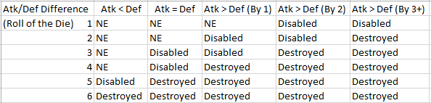

* 1. Disables/Pinned
     1. When a unit is attacked, it has a chance of simply being disabled or pinned instead of being outright destroyed, as depicted in the combat chart below.
     2. When armored units are disabled, they cannot move but they can still attack for a reduced value (-2 attack), though the defence remains.
        1. The armored unit is disabled until the player’s next turn.
        2. While disabled, if an enemy attacks the armored unit and disables it again, the unit is destroyed.
     3. In lieu of being disabled, infantry are pinned.
        1. When an infantry is pinned, they cannot move or attack for one complete turn. However, they get +2 defense.
        2. Unlike tanks, an infantry unit that is pinned must be destroyed, pinning again will reset their wait time.
           1. The infantry unit in question will remain pinned until an entire turn has elapsed without that unit being pinned.
           2. For example, if an infantry squad is attacked and pinned, and on the next turn is attacked and pinned again, the infantry squad still may not move even though it has been one full turn since it was first attacked.
     4. To indicate that a unit is disabled or pinned, flip the tile over (the back will indicate it being disabled).
  2. Special Abilities
     1. Some units have special abilities if they are in the right conditions. Like normal combat these abilities will end movement.
        1. *(Infantry -> Vehicle)*: If an enemy vehicle is on the tile directly next to a garrisoned building, the infantry may attempt to destroy it by dropping explosives on its roof. The owner of the infantry rolls the dice: 5 or 6 means the vehicle is destroyed while 1-4 means the attack was unsuccessful.
        2. *(Vehicle -> Building)*: A vehicle may choose to ram a building with garrisoned infantry in it. The infantry are immediately destroyed and a pile of rubble appears on an adjacent road or grass tile.
           1. The owner of the vehicle must roll the die to determine what happens to the vehicle. A roll of 1-3 means that the vehicle is destroyed while a roll of 4-6 means the vehicle is disabled.
           2. A disabled vehicle remains in the building tile with its backside facing the direction it came from.
           3. The owner of the vehicle may not use the ramming tactic to pass through buildings. When repaired, the vehicle must back out onto the road or grass tile it came from. The building tile retains its normal properties after the vehicle leaves.
        3. *(Infantry -> Infantry)*: An infantry unit can rush a garrisoned opponent and enter the building garrisoned by the opposing unit. Combat is initiated immediately. Roll a die for combat: 1-3 the attacking unit is destroyed, 4-6 the unit previously in the building is destroyed. The victorious unit stays in the building.
  3. Garrisoning Buildings
     1. Only infantry can garrison buildings.
     2. Only a single infantry unit may be in one building tile, except when being rushed by opposing infantry (as described above).
     3. While in a building, the unit receives +1 range to their attacks and +2 defence.

1. **The Goals - Win/Lose**
   1. **Defender**
      1. **Goal:** Maintain control of the White House for 10 turns.
      2. Alternatively, destroy all of the invader’s units on the map.
   2. **Invader**
      1. **Goal:** Capture the White House before 10 turns pass
      2. Alternatively, destroy all of the defender’s units on the map.
2. **Player Interaction**

The main player interaction of our game is the implicit interaction through turn taking. The main conflict between the players results from the strategy that both players choose to make. For example, a good strategic play is luring the opposing units away from a strong point, then proceeding to capture it to gain the advantage. It is a implicit mechanic of our game to apply pressure through unit positioning, potentially compromising units in one area to open up opportunities elsewhere.

A comparison can be made to chess in which a player must decide which pieces are most important to keep in order to win the game.

1. **Unit Types**
   1. Units of our game are divided into several types. While each type does not have defined differences or similarities (with the exception of being able to transport infantry, which will be discussed below), the types’ stats do differentiate one from another. The types are separated into two broad group: vehicles and infantry.
   2. Main Battle Tanks (MBTs)
      1. Main Battle Tanks are heavy combat units designed to push the front-line and engage in the thickest combat. They are tanks (the American M1 Abrams and German Leopard 2 for the US and EU respectively) with massive amounts armor and high range which must, save for a lucky role, be engaged by multiple weaker units or another MBT for hope of successful combat. MBTs are balanced by the fact that they have fewer units available than the weaker ones.
   3. Infantry Fighting Vehicles (IFVs)
      1. Infantry Fighting Vehicles comprise the main body of both sides’ armored forces. The IFVs are have less defence and attack than the MBTs but are usually faster. In addition, IFVs can transport one squad of infantry across the map, allowing for the infantry to stay with the mobile armored forces. Both sides contain a couple of variants of IFVs: the US with the M2 Bradley and the Stryker and EU get the Warrior and the DARDO.
   4. Transport
      1. The Transport type is a US specific vehicle: a HMMWV (Humvee). The transport type is unique in that it has nearly ineffective attack and weak armor but a very high movement value. Like the IFV, the transport can hold infantry and can rapidly move them. The main function of the transport to provide the US with the means to rapidly respond to EU pushes.
   5. Light Tanks
      1. Light Tanks are, like the Transport, a faction-specific unit type, only for the European forces instead of the American. As the name would suggest, Light Tanks are merely smaller, lighter versions of the heavy Main Battle Tanks available to both sides. Light Tanks trade armor and attack for higher mobility and are designed to act in a supporting role as opposed to a main, pushing force like the MBTs (or IFVs in certain situations). The Light Tank is designed to supplement the European forces in assaulting US forces and allow them to overwhelm the defenders.
   6. Infantry Squad
      1. Infantry Squads act as the base units of the broader “Infantry” class. Infantry are good all-’round combat units with decent (but not exceptional) attack, defence, movement, and range. Infantry squads are offered in the greatest number of any type of unit (17 Infantry Squads are available to each side) and designed to create the main bulk of both sides’ Infantry forces. Infantry Squads may garrison buildings for the listed bonuses.
   7. Anti-Tank Squad (AT Squads)
      1. Anti-Tank Squads are units dedicated combating armored vehicles. They have high attack versus vehicles but very low attack vs infantry. As a result, AT squads are designed to fit a very specific situations and do not fare well outside of their comfort zones. Alternatively, a single entrenched AT squad can wreak havoc on multiple vehicles given a proper dice roll and positioning.
   8. Sniper Squad
      1. Sniper Squads are the inverse of AT squads, being designed to specifically combat infantry. Snipers have among the best range of the entire unit roster and can destroy enemy infantry units from well beyond retaliatory range. Much like the AT squads, when outside of specific circumstances, Snipers begin to falter and fall victim to enemies not of the type the Sniper is meant to combat (i.e. Snipers have very high attack versus infantry but very low attack versus vehicles).
2. **Playtests**

The playtests were our main source of information about what we needed to change in our game. Through play testing, we learned in the beginning that our game was very unbalanced, a bit too complex, and several parts of our game were forgotten about by the players. For example, bonuses from the strong points were overlooked, and the special units (the bridge layer, and the repair vehicle) were not used. Overall there was just too much to the game at the start, especially for a beginner, and since a lot of it was not balanced, it only made the game more confusing. We also learned that we really needed to reconsider redoing the units and our combat system. Games ended very quickly, and units were destroyed too easily.

After simplifying the game, and balancing occurred between the units and the combat system, the playtests went more smoothly. There were smaller and fewer problems to fix in the game. Instead of having to rework a whole combat system, for example, we would have a couple of units to change some numbers on.

The final playtest we did took about two hours. The results and observations were promising. The invader (EU) won with less than 10 units left by rushing the White House. The game lasted two full turns plus one extra invader turn. The defender (US) would have won if the invader was not able to rush the infantry in the White House. (See special abilities). Overall the game seemed fairly balanced. Each side seemed to lose five to ten pieces per turn. The ability for the invader to come from behind can be interpreted as a good sign of asymmetrical play, but we would need to see the defenders come from behind to ensure the invaders are not superior when behind or ahead.

Finally, the amount of actions available to players and the amount of things to keep track of in the game seemed more reasonable, creating a playable game with a nice flow. The game overall felt less overwhelming complex. The special attacks were used, such as rushing an infantry unit in a building, rubble was used, the invader remembered to bring in reinforcements and use the bonus from the strong points, and bonuses from buildings were used in combat. The majority of the abilities and different actions in our game were remembered and used effectively, which was a major step up from our original playtests where abilities and actions were forgotten and not used at all. There is still some balancing that could be done, and there are features that we would have liked to add (see the improvements section), but we were pleased with the final playtests.

1. **Balance Issues**

We encountered several balance issues when creating the game including:

* 1. **Combat**
  2. **Board**
  3. **Units**
  4. **Complexity**

1. **Combat**

One balance issue involved the dice rolls and the combat results table. Originally, we had a combat results table like ogre, and when attacking, each piece's attacked was increased by a roll of a D6. An attack number corresponding to the combat results table was calculated by the attacker's newly increased attack divided by the defender's defense. Because we used the D6, an attacking unit almost always fell into the last column of the combat results table, which resulting in destroying almost any unit they attacked. It also gave whoever attacked first a huge advantage, as they could destroy a large number of opposing units before the other player even had their first turn. At first, we weren't sure if players were just having lucky high dice rolls but as the problem persisted, we decided to lower the D6 roll to a D3.

Even after fixing the dice rolls, we found that this did not help balance the issue where whichever player attacks first gets a huge advantage. After brainstorming some possible solutions such as having one team go first while another team starts with more units, we received a suggestion from the professor that counter attacking had been successfully added into other games. We thought this could work, and added it into our playtests to try. This did work much better with our game. Because of our high number of units for each team, we realized that letting the attacked units counter attack helped balance the issue of one player going first. The player who attacks first could not simply destroy several of the other player’s units and leave completely untouched. It made the attacking player think before attacking, as they now would have to consider what the likelihood of a unit being destroyed by a counter attack was, and pick their attacking units and targets more carefully and weigh the consequences.

However, although adding counter attacks greatly increased the balance of the combat system, we realized through this new addition that our pieces were very unbalanced and that there was still a very high chance of units being destroyed. For example, the results of combat that we observed after adding in the counter attacks was that the attacking player still had a high chance of destroying the defending player’s unit, and through the counter attack, the unit being countered against also had a high chance of being destroyed. This made combat less enjoyable, as it almost felt as though attacking a unit would guarantee that your unit would be destroyed.

We then had to redo all our units’ values to fix this solution, as well as create a new combat table. Our new combat table was much simpler than the original. Instead of finding a ratio between the attacker’s attack and the defenders defense, we compare the attack and defense directly. For example, we compare whether the attack of the attacker is less than defense of the defender, the attack is equal to the defense, or the attack is greater than the defense. Depending on whether the attack is less than, equal to, or one, two or three greater than the defense, there is either no effect, the unit is disabled, or the unit is destroyed. The combat results are similar to the original ogre combat table, except we changed how we determined which table of the results to use. This made it simpler to understand, for ourselves, and for any new players, because, for example, we didn’t have to try to explain how to calculate which column the results would be in if the attack and defense ratio came out to be a decimal. We originally stated to round in the favor of the defender, but we wanted to simplify it even more.

1. **Board**

Our board went through several iterations throughout the course of the game’s development. The first order of business was picking a suitable location for the game to take place. In conceptualizing the game, we wanted a real life location for the combat to take place, specifically a modern city. We had to balance our city to be the right mix of tight, claustrophobic streets and buildings and wide open space for large scale engagements. Furthermore, we wanted our city environment to contain waterways and bridges to capture the unique combat style of fighting for and holding bridgeheads.

After several days of deliberation, we finally settled on the location of Washington DC. The city offers the desired mix of both close and open combat. The northern and eastern portions are heavily populated with buildings and roads, provided the key element of close, street battles between armored units and building-to-building fighting between infantry units. The southern and western portions of the city contain the Washington Mall and the area outside of downtown Dc and thusly open up, allowing the second part of our combat to flow (the open, fast moving, fluid combat). Finally, though it is somewhat bigger than would be useful and off center on our map, the Potomac River and the several bridges that cross her provided the third type of combat we were looking for, as mentioned above.

In actually creating the board, we struggled with how precise and detailed we should be when constructing the map. Confined to relatively small dimensions of 17” X 22”, we struggled with how to fit as large a space as possible into the provided parameters while still making the individual features of the map readable and recognizable. Finally, we settled on a rectangle ranging roughly from just past the Lincoln Memorial to just past the the US Capitol Building (West to East) and from north of Washington Circle and Lafayette Park to the southern bank of the Potomac (North to South). While our individual tiles were still very small, we were still able to preserve the recognisability of downtown DC and the surrounding area.

When actually designing the map, we made several changes. Most notably, we originally were going to make the map an actual map of the city divided by hexagons. However, after some playtesting, we discovered that the map was very difficult to read and that it was nearly impossible to determine what properties each tile had. As a result, we changed the map from being an actual map to being an approximate representation of the location filled with different, colored tiles with each color denoting what each tile was. This allowed our board to be much more easily readable. In addition, we initially had decided to include several types ranging from small alleyways to large highways. However, upon playtesting, we determined that this was much too complex and instead, merely condensed all road passageways into a broad “road” tile.

When designing the map, we also had to consider line of sight and in range, which was a slightly confusing process. For example, “in range” was determined by counting tiles that could be shot through. (If you were on the opposite side of a building from the unit that you wanted to attack, you would count spaces around the building to determine how far you were away.) However, “line of sight” was determined by a straight line on the map from one unit to another, which seemed to conflict with the “in range” calculation. However, because our streets could lie between many buildings, if we calculated “line of sight” the same way “in range” was calculated, the sides and backs of units might become the only parts attacked, which seemed unbalanced. So, we decided to keep our calculations the way they were for balance with attacking and just be very specific in the rules as to avoid confusion from the player.

1. **Units**

The units of our game went through several changes, as well. The first order of business of our game was deciding what factions would be combatting one another in the game. We knew that we wanted our game to take place in a modern setting with realistic units, so that narrowed our choices down to the modern militaries that could field an army’s worth of cutting-edge weapons and vehicles. Picking our location narrowed the choices even further as Washington DC is the seat of power of the United States, meaning that the American Military would almost be mandatory to be one of the opposing parties. The opponent was a little more difficult to determine. While the standard “enemies of America” (Russia, China, etc.) would have sufficed, we decided to make our second faction a little unorthodox and chose a militarized European Union composed of the combined military force (and units) of the 20 or so nations that comprise the union. This gave our game an air of uniqueness while still remaining within the confines of realistic, modern military conflicts.

After determining our faction, we had to pick each side’s units. The two factions are mostly symmetrical with a several infantry unit types and a variety of armored vehicle types. While there are many more types of vehicles than there are infantry, there are many more units of each infantry type available than any one type of vehicle. This means that both teams have about half vehicles and half infantry, just with more variety among vehicles. Both factions have one Main Battle Tank and several different types of Infantry Fighting Vehicles. However, both sides also receive unique types of units. The US receives a low damage/high mobility Transport to rapidly re-deploy along the shifting front line while the EU gets a Light Tank type to assist in assaulting fortified US positions. We felt that this would assist in making each side feel unique but still remain similar enough to easily play both.

The biggest problem our playtests showed us was that almost every unit had too low armor and too high attack. This allowed half of a team to be decimated in the first round of combat. We countered this by reducing the attack value of nearly every unit as well as increasing their defencive values across the board. While this helped a great deal, entire teams were still being lost in just two combat engagements. To counter this even further, we added a mechanic that allows an attacked unit to counter-attack the unit attacking it. This meant that combat was not only much more dangerous and realistic, but more importantly the general team sizes are kept at a consistent ratio throughout the entire game, making it more-or-less balanced throughout the entire playthrough.

A second big issue of our testing was that infantry were severely underpowered and were being decimated by armored vehicles. This was because we initially wanted to make the game as realistic as possible; and realistically, an infantry squad does not have the armor or firepower of a 60 ton battle tank. We felt that between the garrisoned buildings, rubble being detrimental to tanks, and the much weaker rear armor value for vehicles, the infantry would be able to go toe-to-toe with tanks and IFVs in the urban environments. This however did not prove to be true. To compensate, we increased the infantry’s abilities all around, giving them better attack, defence, and movement. In addition, we gave the infantry a special ability to drop explosives on vehicles next to buildings, requiring vehicles to be much more cautious when close to enemy infantry.

1. **Complexity**

Our game was very complex and had to be changed on a few occasions to assure proper balance and playability. We designed our game in the guise of a tradition war game with prodigious rules, a long set-up time, even longer play time, and a vast amount of complexity when playing the game. We were able to achieve this and our game was suitably grandiose in scale. However, while our game was big and complex enough to satisfy hardcore, seasoned war gaming enthusiasts, it was more than a little difficult for novice players to get into. In addition, some of the rules were a little too complex and led to confusion. Finally, some our units were seen as either redundant or of no use.

Our game takes roughly a half an hour to set up when experienced players are playing and can take even longer for novices to do so. To rectify this, we decided to create a “Quick Start” rule sheet of about a page that would allow players to get the bare gist of the rules without having to sift through the seven or so pages of actual rules. In addition, we reduced the girth of our actual rules by rewriting sentences, cutting out redundant statements, and condensing sections. Overall this drastically reduced our setup time for both novice and experience war game players. By cleaning up our rules, it also made them easier for players to read in the actual game, allowing the game to progress much more quickly and less frustratingly.

A large issue that was tackled was some unnecessary units. Our biggest change to the units was removing the “Special Units” on both sides. Initially, each side had specific units that allowed the team to act in a specific way that would be beneficial. The US team received Combat engineers which acted as normal combat infantry squad but with the ability to demolish building and bridges to impede the EU’s progress, as well as repair disabled friendly vehicles. The invading EU received two units: the Bridge Layer and Armored Recovery Vehicle (ARV). These units would allow the invader to cross the Potomac after it’s bridges were destroyed and clear rubble and repaired disabled vehicles respectively. While the group liked these units and felt that they were balanced, after numerous playtests, we determined that these units were not being used at all and were thusly unnecessary. In addition, the different functionality that they afforded each side took up a large part of the rules and significantly complicated them. As a result, we decided to kill two birds with one stone and remove the Special Unit; simultaneously simplifying the rules and gameplay and also taking out an unnecessary and potentially confusing units. In addition, we deemed that a few IFV variations were redundant and removed them from the unit roster so as to give the players a simpler choice.

1. **Group Dynamics**

**Meeting Times**

Our group was pretty consistent when it came to meeting times during the week. We met during the free time during class, during work days, and used the cancelled class to have a meeting at crossroads that morning. We also met every Tuesday and Thursday for an hour and a half. It was a pretty tight amount of time especially since our game took at least forty five minutes to set up. It was hard to get through full playtests. We had to make the best of our time.

Each meeting time, we alternated who would playtest the game, while the other two group members would work on other aspects of the game. The playtesters would choose different units and different strategies each game, create scenarios to test the combat system, and read through the rules while playing to try to ensure that they were consistent, up to date with our current ideas, and were clear. If they found anything in the rules that was out of date or written unclearly, they would be in charge of changing the rules. The other two teammates would work on anything else that needed to be done. For example, creating an updated board, updating the combat system, balancing numbers on units or fully remaking them, and updating our combat results table data and unit table data.

On several occasions, our meeting times were not enough and we had to meet on either Saturday or Sunday afternoon when we were all free. This is when our full playtests would occur that we usually did not have time for during the Tuesday and Thursday Meetings. Our playtests would take about two hours. Again, the two people not playing at the time would be updating rules and pieces, and watching observe the balance, or lack thereof in the game. We also utilized weekend meetings to playtest the other group’s game. During these playtests, all four group members were involved purely in the other group’s game. Two would play, while two would watch, comment, and help write down notes, and then we would switch roles, and do a second playtest.

**Group Debate**

We did have a few debates in the group concerning our game. Usually these debates were related to what was included or not included in the game. For example, some discussions were related to how powerful some units should be against other units, specifically the sniper. We were worried about making this unit too powerful or too weak. One discussion was related to whether the sniper should have any chance of hitting an armor unit. The logic supporting that they should not be able to hit them was that real life snipers are specifically anti-infantry units. The logic supporting that they should have a very small chance of hitting tanks was concerning balance, as to not make the players want to avoid using snipers if they are effective against fewer units. We decided to have the snipers have a very small chance of hitting armored units, for balance’s sake.

We also had another debate concerning the speed of the sniper. We had to decide whether or not to allow the sniper to move five tiles per turn or two tiles per turn. The concern was avoiding making the snipers move too fast with such a high range, while also avoiding making them too slow and being left behind from the other, faster units. We decided to compromise and give the snipers a movement of four and lower the range of from seven to six. This helped both arguments, and we think that it was a good balance for the sniper unit.

We got some feedback that our game was a little too complex for beginner players, so a big discussion that we had was to determine what pieces of our game seemed too confusing, or unnecessary. However our debate related to how much to remove from the game. We agreed to remove some units (see the previous unit section) from the game that were not crucial to the gameplay, such as the specials which seemed to be forgotten in game play, and units that were very similar. This allowed us to simplify the choices for the player, as we figured that novice war gamers wouldn’t know the difference between very similar units. Because we removed the specials, we also had to remove the destructible bridge tiles. We also agreed removed most of the bonuses from the strong points, except for that the invader would get reinforcements based on the number of strong points that they had control of.

Some of the things that we debated about taking out was rushing infantry in buildings, and dropping explosives onto roofs of vehicles from buildings. The argument to support taking them out was that for a novice war gamer, having too many things to do might be overwhelming, especially when reading the rules, and it could be forgotten about when playing because of this. The argument to support keeping them in the game was that novice war gamers could forget them, but they are there for extra play abilities when they feel comfortable with the game, and for the more experienced war gamers. In the end, we decided that keeping them in the game was a good idea. We also came up with a solution of creating a condensed sheet of rules that are less overwhelming to read for a beginner player to use. This sheet would explain the basics of the game, while the longer, more detailed set of rules could be used by experienced war gamers, and after the beginners read the short version and understood the basics of the game.

**Group Problems**

We ran into a few group problems throughout the semester. One of the sources was a lack of communication in the group. We mainly communicated in a facebook chat outside of class and our meetings, and there were not guaranteed to be seen immediately. This type of communication made immediate work that needed to be done difficult, because we all checked our messages at different times, and messages can be easily missed.

We also had a bit of trouble with our meeting times. We all have very different schedules, and our Tuesday and Thursday meeting times were almost the only time during the week that we all had open to meet. If we had to do another meeting during the week, sometimes the weekends were not free for everyone, especially on short notice. This meant that some people could work in person while others could work from a computer they could get access to. It made making progress difficult because communicating over a chat between the group is slow and we didn’t want to make drastic changes without everyone’s approval and knowledge that the changes were taking place. Sometimes this resulted in different members of the group having different information about the most updated game. Again this was trouble with communication, as well as trouble actually meeting in person.

Finally, one thing that set us back was having one copy of the game. If someone had the copy of the game, and was either late to a meeting or not able to attend, our progress would come to a halt until we were able to figure out how we could work on the game without having the game. Usually we resorted to working on balance, clarifying our rules, or attempting to successfully redesign the pieces to be more readable.

1. **Issues that we had**

**The game pieces**

Our game pieces and board were difficult to work with throughout the whole project. Because of the board size limitation of 17 inches by 22 inches, and our choice to make the map a layout of washington dc, our map tiles had to be very small to create the effect that we wanted. As stated previously, we wanted the map to be recognizable as Washington D.C., so the map tiles had to be very small and detailed, meaning that the unit pieces had to be tiny as well. We came up with several designs and layout of information for the game pieces. We eventually settled on one, except it was very close to unreadable without a magnifying glass, as some of the font was down to size three. Throughout the whole process, we were trying to think about how to make the pieces more readable because we were not happy with them at all. We eventually spent one of our meetings redesigning a new piece layout and doing a print test to see if it was readable. We worked in the labs on these pieces so we were able to ask other people to take a look at our pieces and tell us if they were readable. We decided that we weren’t the best judges since we already knew what was written on the pieces.

We also were a little unorganized with the unit piece data charts. We would update the values on the units for example, without updating the charts that were in the rules. This was a problem because we used this chart when creating the final unit pieces in photoshop, so this made the process confusing. It required a lot of communication to make sure that we were actually putting the right number values on the units. We had to work together during this part so that one person could update the chart with the data, while another person created the unit pieces.

One of the last problem with our pieces is that they were originally made out of regular printer paper. This made it very hard to tell which units belonged to which team when they were on the board. We temporarily fixed this by drawing a yellow dot on each piece for one team. However, for the final submission, we printed the final units on blue and green colored paper, which made the units much easier to tell apart. Finally, because they were printed on paper, they were very light and easily were blown off the board. There were several playtests where we would either breathe or laugh too close to the board and half of the pieces would fly away, and we would have to guess where to put the pieces back.

1. **Future Improvements**

If we were to continue this game outside of the class, we would like to increase the size of the board. We made the board the maximum size that we could for the class, however, if we were to make it slightly bigger, the game pieces would be able to be increased in size, therefore being more readable, and the map would be able to be more accurate and realistic.

Because our pieces were so light and easy to blow off of the board, we would greatly consider finding a nice material that would be decent and reasonable for a game piece, but also sturdy enough to stay in place on the board. We had considered using a magnetic board but did not have the resources to do this. In the future we could create this magnetic board if we so choose, or even have the pieces and board printed on plastic, a type of cardboard, or another type of material. This would also make the game pieces thicker, so that they could more easily be picked up and moved when playing.

There were also aspects of the game that we removed due to time constraints and for the sake of simplicity. We had considered, for example adding aerial units, but figured this might be a reach goal for the 15 week project, as the ground units would need significant time to balance correctly without considering how aerial units could affect the game play. For simplicity, we also removed our bridges, special units, and special bonuses from controlling the strong points, parts of the game that we were excited to try to implement. There simply wasn’t enough time to try to balance everything, so we had to put something aside in order to create a coherent game. We saved all of these removed ideas in a separate document and would strongly consider working with these again on our own time to balance them and add them to the game.

1. **Success**

Overall, even with the problems that we had, we did all enjoy working on the game and all supported the progression and improvement of the game. We thought our game idea was a fresh and new since the conflict was between the US and the EU, and we hadn’t seen a game based on Washington D.C. before. We were excited about making the game as accurate as possible and fun at the same time. After making significant progress, such as the creation of the first and second board and the game pieces, we were excited to start to see the game come together, as opposed to just being a hypothetical game idea. Some of us had never played a wargame before, while others were already very interested in war games before taking the course, so we all are proud of the game that we were able to create. We were able to create a functional game that we, and others, have enjoyed playing, and think it would be worthy of being a portfolio piece for ourselves.

Bibliography

Jackson, Steve. *Ogre Pocket Edition*. 2-17. Print.

"List of Modern Armoured Fighting Vehicles." *Wikipedia*. Wikimedia Foundation, 9 Aug. 2014. Web. 18 Sept. 2014.

"Military Guns of the World." *Military Guns*. Military Factory, 14 May 2014. Web. 18 Sept. 2014.

"Military Tanks, Armored Vehicles and Artillery of the World." *Military Tanks, Armored Vehicles and Artillery*. Military Factory, 7 Apr. 2014. Web. 18 Sept. 2014.

"MILITARY TODAY - Everything About Modern Warfare." *MILITARY TODAY - Everything About Modern Warfare*. N.p., n.d. Web. 18 Sept. 2014.

"Washington,+DC - Google Maps." *Washington,+DC - Google Maps*. N.p., n.d. Web. 18 Sept. 2014.